1. **Write a program to convert Decimal number to Binary number using any high level language.**

n=int(input("Enter decimal :"))

sum=0

m=1

while n>0:

r=n%2

n=n//2

sum=sum+(r*m)

m=m*10

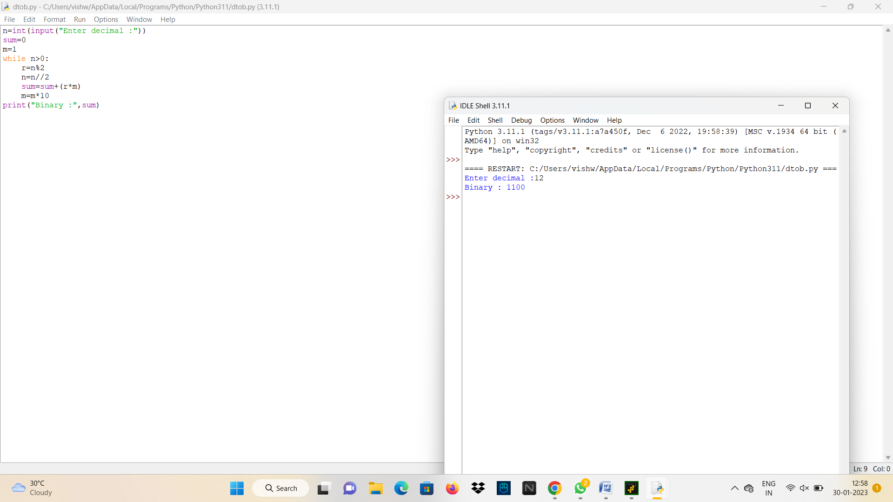print("Binary :",sum)